CIS 1111 Programming Topic 6 – Calculating Shipping Charges
(20 Points)

Assignment Description:
In this assignment, you will develop both a C++ program and a Raptor program that calculates shipping charges for a freight shipping company. Write a program that asks the user to enter the weight of the package and the distance it is to be shipped, and then displays the shipping charges. Do not accept any packages that are over 50 pounds. Also, do not accept any packages that are to be shipped a distance of less than 10 miles and over 3,000 miles.
Below is the chart to use to calculate the shipping charges.

Freight Shipping Company Rates
______________________________________________________________
Weight of Package (pounds) Rate per 500 miles shipped
_______________________________________________________________
5 pounds or less $1.10
Over 5 pounds but not more than 15 $2.20
Over 15 pounds but not more than 30 $3.70
Over 30 pounds but not more than 50 $4.80
_______________________________________________________________
NOTICE: We do not ship packages over 50 pounds
We do not ship less than 10 miles or more than 3,000 miles

Requirements for your program:

- The output must be labeled and easy to read as shown in the sample output screens included in this document.
- When the packages are over 50 pounds or the distance is less than 10 miles and more than 3,000 then flag the input and display a description error message.
- Use a logical operator when testing the distance to be shipped.
- Use an if-else statement when determining the rate per 500 miles to be shipped given the weight.
- Calculate the number of segments. Round the segments up to next whole number. Hint user modulus.
- Multiply the number of segments * the shipping rate.
- Your program must be documented with the following:
  - // Name
  - // Date
  - // Program Name
  - // Description
- Code and execute the Raptor program

Sample outputs:

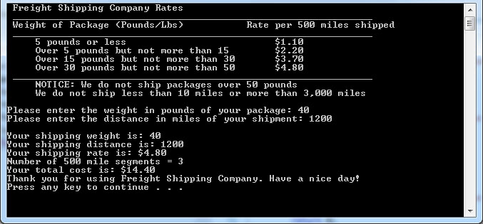

Submit:
Zipped folder named LastNameFirstNameCIS1111NameOfAssignment which contains:
- Your .cpp file
- Screen shots of your code and output
- Your Raptor program and screen shots

Grading Guidelines for This Assignment
 | Range – Low End  (Did not do or did very little effort) | Range – High End  (Used correctly and spent time/effort on programming)
Names of variables are meaningful and the program comments self-document the program | 0 | 2
Met all stated requirements including developing the Raptor program | 0 | 10
Output is correct given the input, and the output is correctly formatted | 0 | 4
Program compiles and executes without any runtime, syntax, or logic errors | 0 | 3
The zipped project folder that includes the C++ .cpp source files and screens shots of the code and console, and Raptor program and screen shots is uploaded to drop box. | 0 | 1
Total Points Possible | 0 | 20

